Lunar lander game plan

The starting page

- Create a starting page with info about how the game works and a start button.

The game page

- Create a background with a star sky. The stars should be in different sizes and have different brightness to them.

- Create the moon as the landing surface. The moon should cover the bottom half of the page.

- Create spaceship.

- Code velocity to the spaceship when it falls and configurate the space button to fly the spaceship.

- Add flames to the spaceship engine when the space button is pressed.

- Add the amount of speed the spaceship can land on the moon without crashing. If the landing is soft = you won the game, if not = you lost the game.

- If time: Add planets and a cat to the background to create a more interesting background for the game.

The end page

- Add text “You won” or “You crashed, try again”.
- Add a restart button.

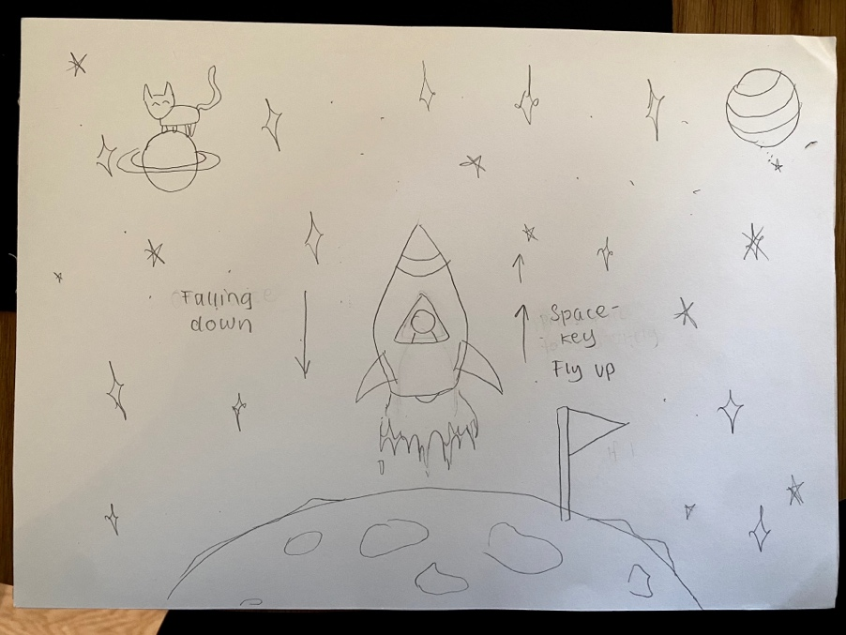

I will start working on the graphics of the
game and then work on the game page.
I will focus on getting the velocity right
for the falling of the spaceship and then
work on the flying with the space key part.

After the game page works, I will move on
to the start and end pages.

